**Title: Simple View Calculator**

**Description**: Create a simple calculator that can add, subtract, multiply and divide. This will be a WPF application where all code will be in the view (i.e. view.xaml.cs). Your calculator may look something like this:

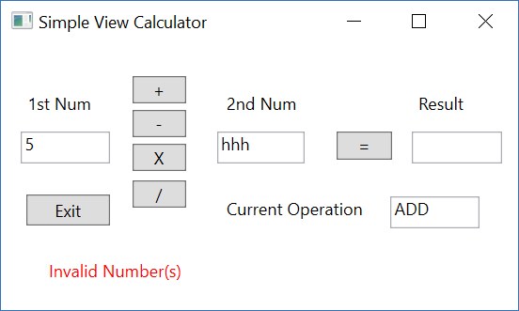

Your calculator should also have a status box that could display user input errors. Above, the user tried to enter alpha characters, and the condition was recognized by placing “Invalid Number(s)” in the status box.

Your calculator should also have an Exit button.